**Birds of a feather flock together: Social context exacerbates the effects of light pollution on circadian disruption.**

Cassandra K. Hui, Yong Zhang, Jenny Q. Ouyang

**Methods**

ChronoShop program used for viewing and the analysis circadian properties in activity data can

be downloaded from: https://dataverse.nl/dataset.xhtml?persistentId=hdl:10411/YHJEFV

**Results**

**Supplementary Table 1:** Primer sequences designed based on Zebra Finch *cry1*, *bmal, per2*, *per3,* and 18S genes for qPCR.

|  |  |  |
| --- | --- | --- |
| **Primer** | | **Sequence (5’- 3’)** |
| *cry1* | forward | GGTCTTCTTGCAACTGTGCC |
| reverse | AGCTGAGCTCCTCCTGTACT |
| *bmal1* | forward | ATGGCTGTCCAGCACATGAA |
| reverse | CACAGCCCACAACGAAAAGG |
| *per2* | forward | AGCAAGACCTGATGCCTGTC |
| reverse | ACATCGGACGTGAACAA AA |
| *per3* | forward | TTGTGGCCAAGGTGATTCCC |
| reverse | TGTCTCTGAGGTTTCTGGCG |
| *18S* | forward | GCCGCTAGAGGTGAAATTCTTA |
| reverse | CTTTCGCTCTGGTCCGTCTT |

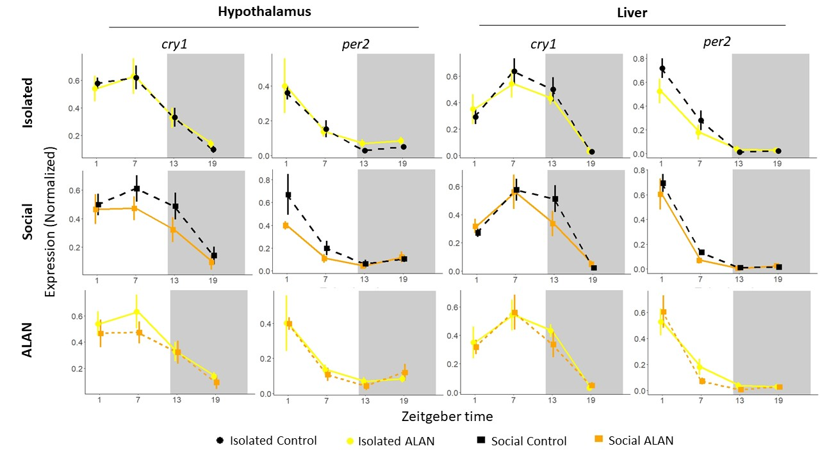

**Figure S1. Daily circadian gene expression in the hypothalamus and liver under ALAN.** Normalized expression of *cry1* and *per2* collected at four time points throughout the day. Shaded portions represent nighttime (ZT 12-ZT 24). Samples were collected after 10 days of ALAN exposure at ZT 1, ZT 7, ZT 13, and ZT 19. There were no significant differences between treatments. Data reported as mean ± SE.

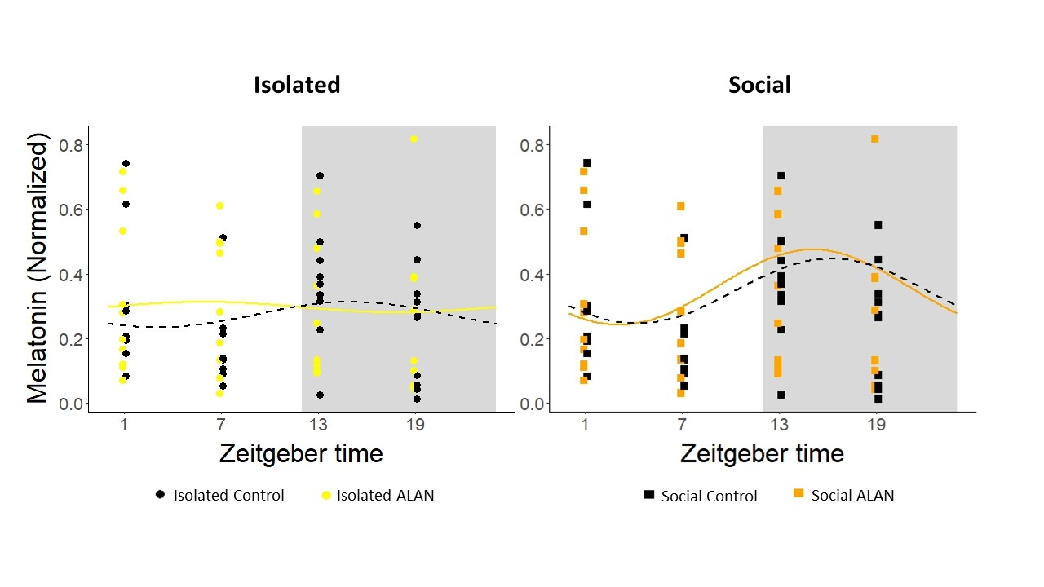

**Figure S2. Daily melatonin levels do not differunder ALAN across social conditions.**Circadian rhythm of melatonin with fitted cosine curve overlaid. Shaded portions represent nighttime (ZT 12-ZT 24). The left panel shows birds in isolation and the right panel shows birds in social conditions. Samples were collected after 10 days of ALAN exposure at ZT 1, ZT 7, ZT 13, and ZT 19. Significant differences were not detected between birds exposed to ALAN and control birds in either isolation or social groups. Points represent individuals.

**Table S2.** Rhythmic analysis comparing the difference in phase of expression of four circadian genes in the hypothalamus between birds exposed to ALAN and controls either in isolation or social conditions. Four time points were collected throughout the day at ZT 1, 7, 13, and 19.

|  |  |  |  |
| --- | --- | --- | --- |
| **Condition** | **Gene** | **Difference** | **p-value** |
|  | *bmal1* | 0.70 | 0.77 |
| Isolated | *cry1* | -0.14 | 0.89 |
|  | *per2* | 0.61 | 0.63 |
|  | *per3* | 1.20 | 0.08 |
|  | *bmal1* | 5.00 | **0.01** |
| Social | *cry1* | 1.44 | 0.36 |
|  | *per2* | 0.96 | 0.55 |
|  | *per3* | 1.70 | 0.05 |